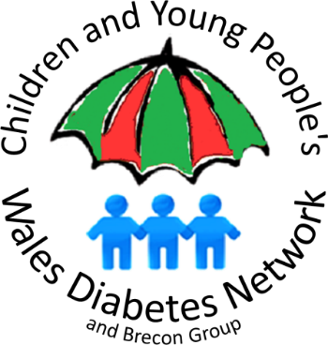**The Children and Young People’s Wales Diabetes Network**

Office Address: Cardigan House, University Hospital of Wales,

Heath Park, Cardiff, CF14 4XW

Network Manager: **Jon Matthias**

**Jon.Matthias@wales.nhs.uk Tel. 07989 193175**

**Message for parent mail:**

Dear Parents,

The NHS has asked for this message to be sent out to you.

Undiagnosed Type 1 diabetes in children requires urgent medical attention

If your child has ANY of the main symptoms of Type 1 diabetes please make an **urgent** GP appointment or contact the Out of Hours service. The main symptoms are known as the 4 Ts – Thirst, Toilet, Tiredness, Thinner. If you notice your child is thirsty or using the toilet more frequently, is always feeling tired, or has lost weight recently, seek immediate medical advice.

NHS services are very well equipped to look after children safely if they are unwell. Please do not delay seeking medical advice because of Covid-19.

There is more information available here:

<https://www.diabetes.org.uk/in_your_area/wales/campaigning/know-type-1---wales>