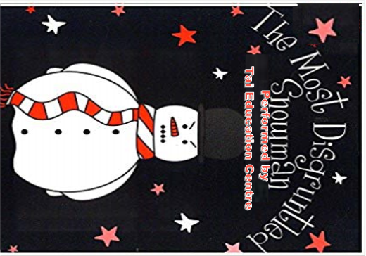

At Tai Centre

On Thursday

12th December at 10am